Wire shark lab 1

Part 1.

These are the questions:

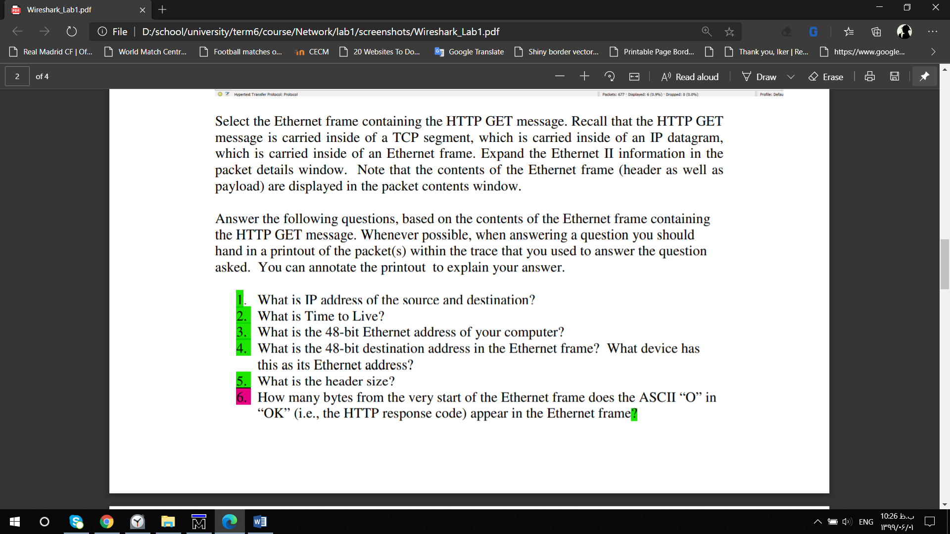

And the screenshots of the answer are:

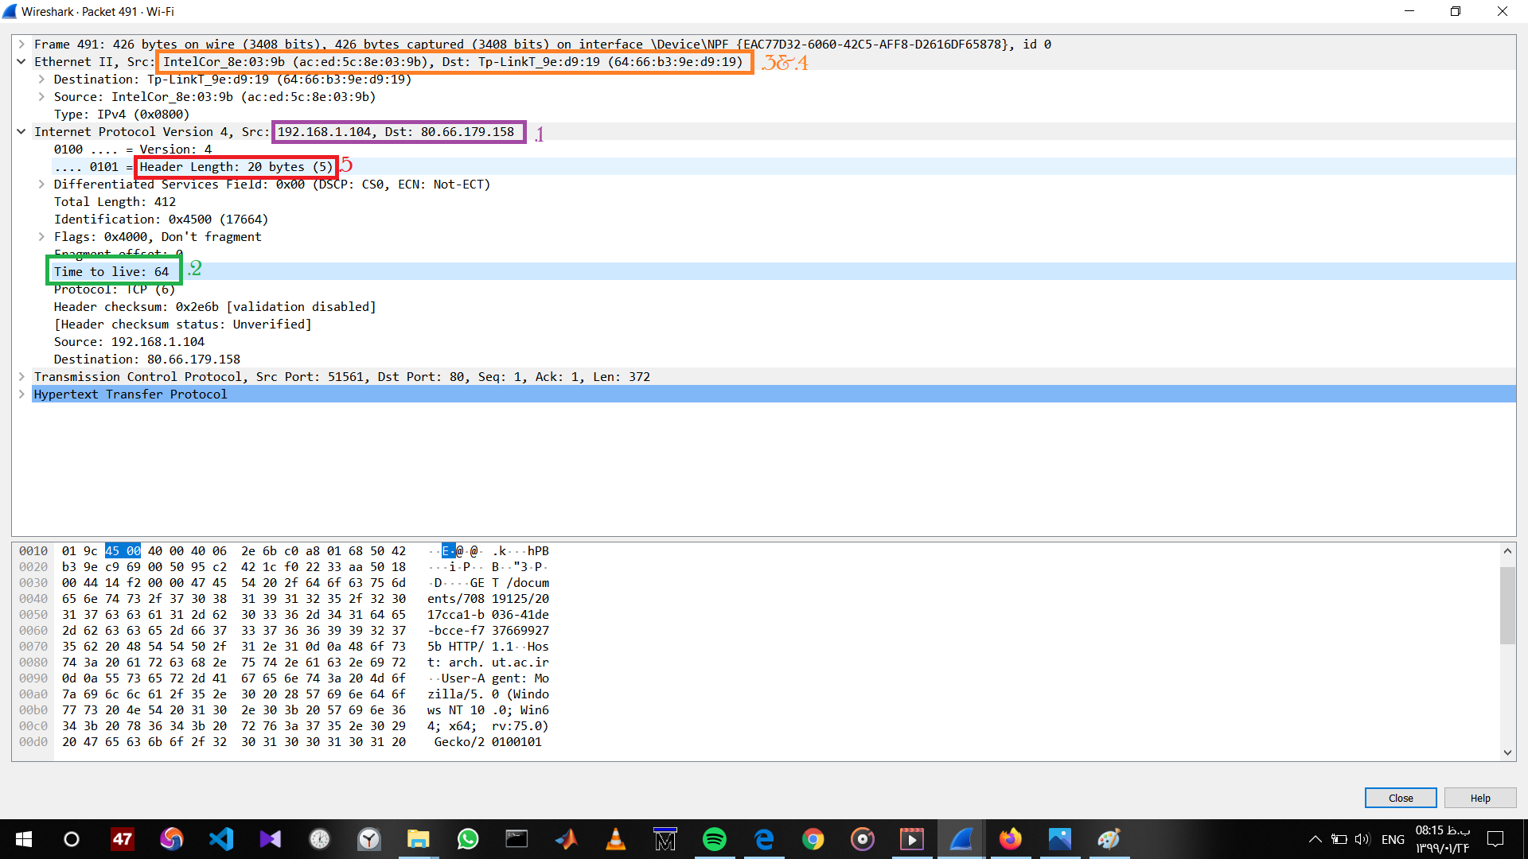

There are 67 bytes before the “O” (or “O” appears as the 68th byte). These bytes include the Ethernet frame, the IP header, the TCP header, and some HTTP preamble text.